1. Technical Specification

Platform: Cross-platform app (React Native)

Programming Languages: JavaScript & Python

Stylistic Conventions: JavaScript Style Guide & Python Style Guide

SDK: Facebook SDK

IDE: Visual Studio Code, PyCharm

Tools/Interfaces: Mobile devices

Target Audience: people who want to invest in stocks

1. Environment Setup and configurations

In terminal, get info correct folder **getData**.

Then type in python3 stockdata.py.

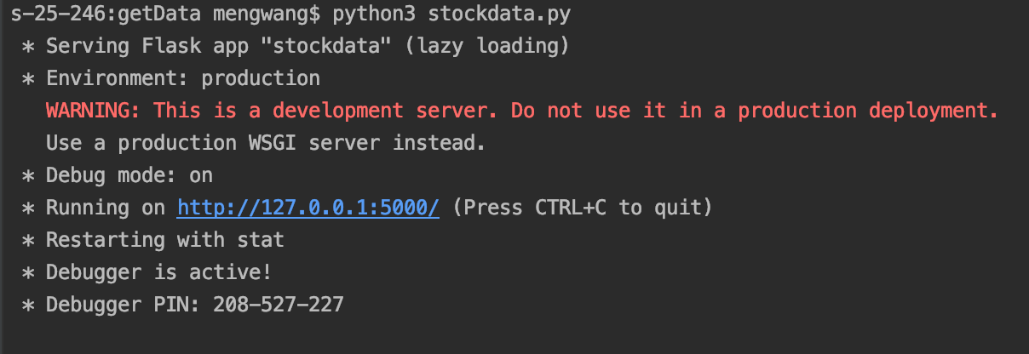

1. Operations and the results: API

Open link: <http://127.0.0.1:5000/api/stock_info?stock_name=MSFT>

We can get stock info of MSFT as following:

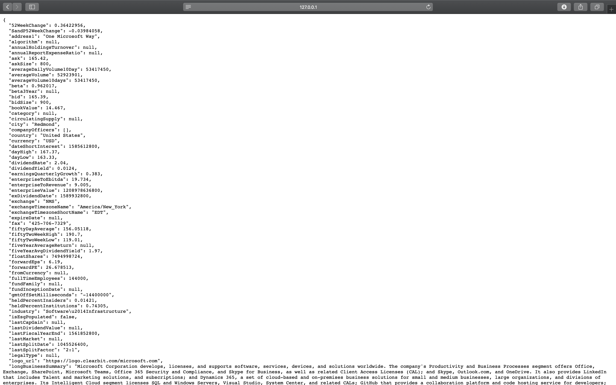

Open link: <http://127.0.0.1:5000/api/stock_data?stock_name=MSFT&stock_period=30d>

We can get stock MSFT’s recent 30 days close prices as following:

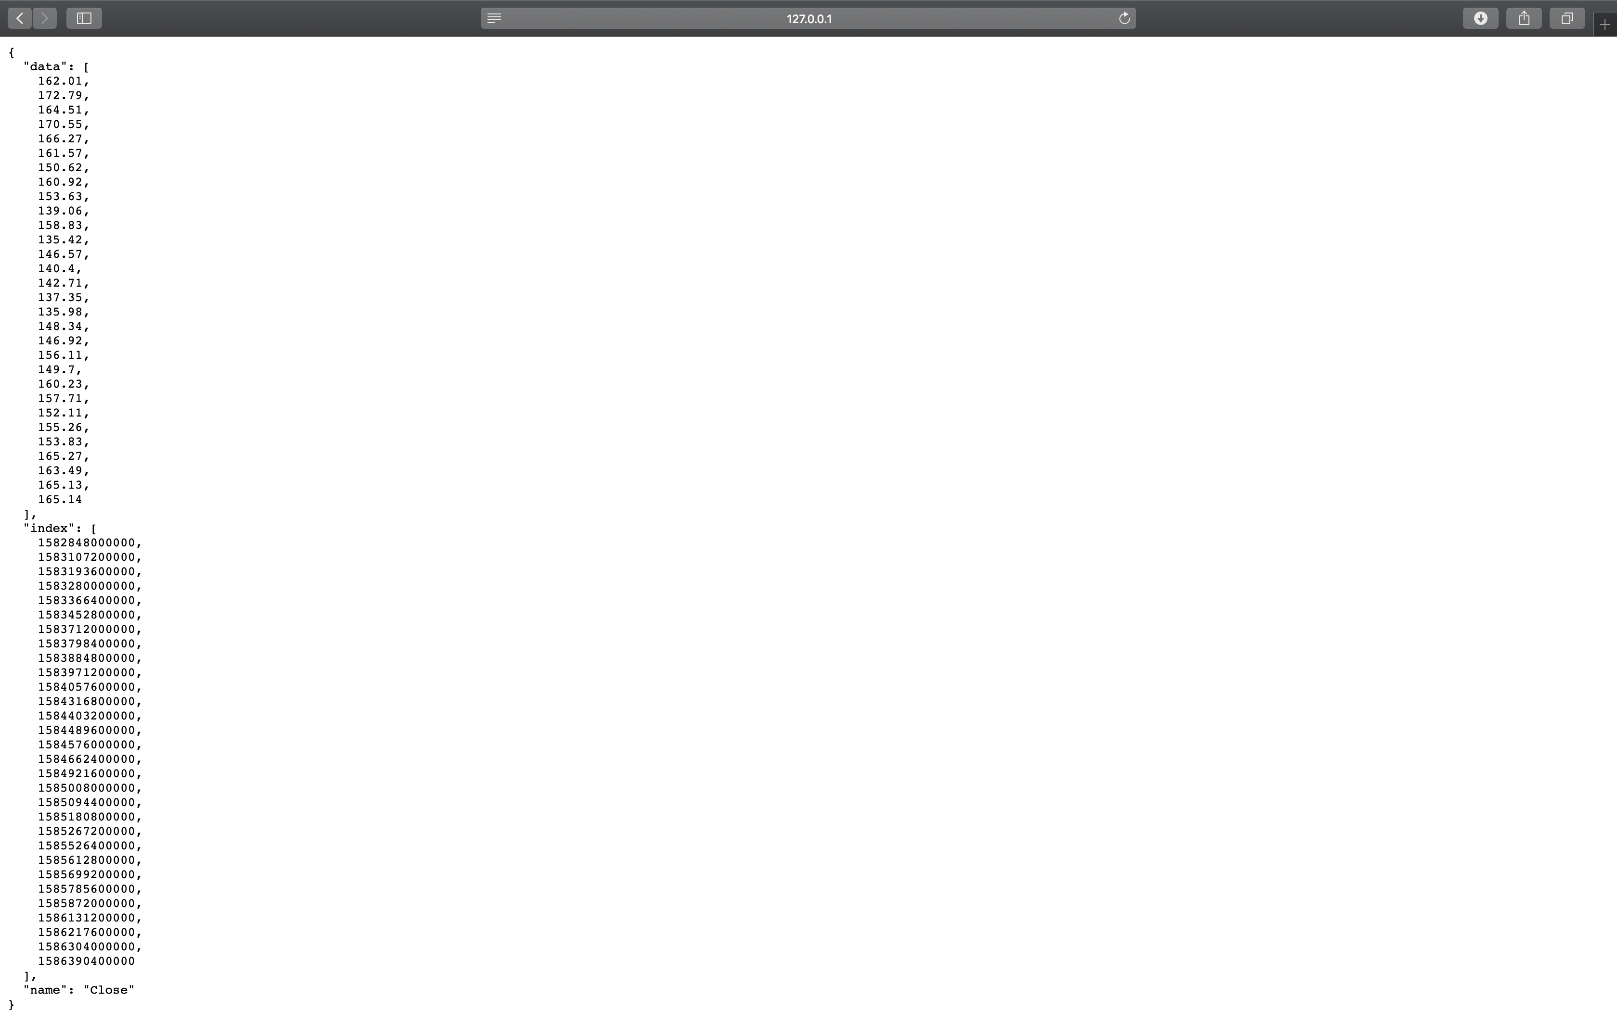

Open link: <http://127.0.0.1:5000/api/financial_news>

We can get recent financial news as following:

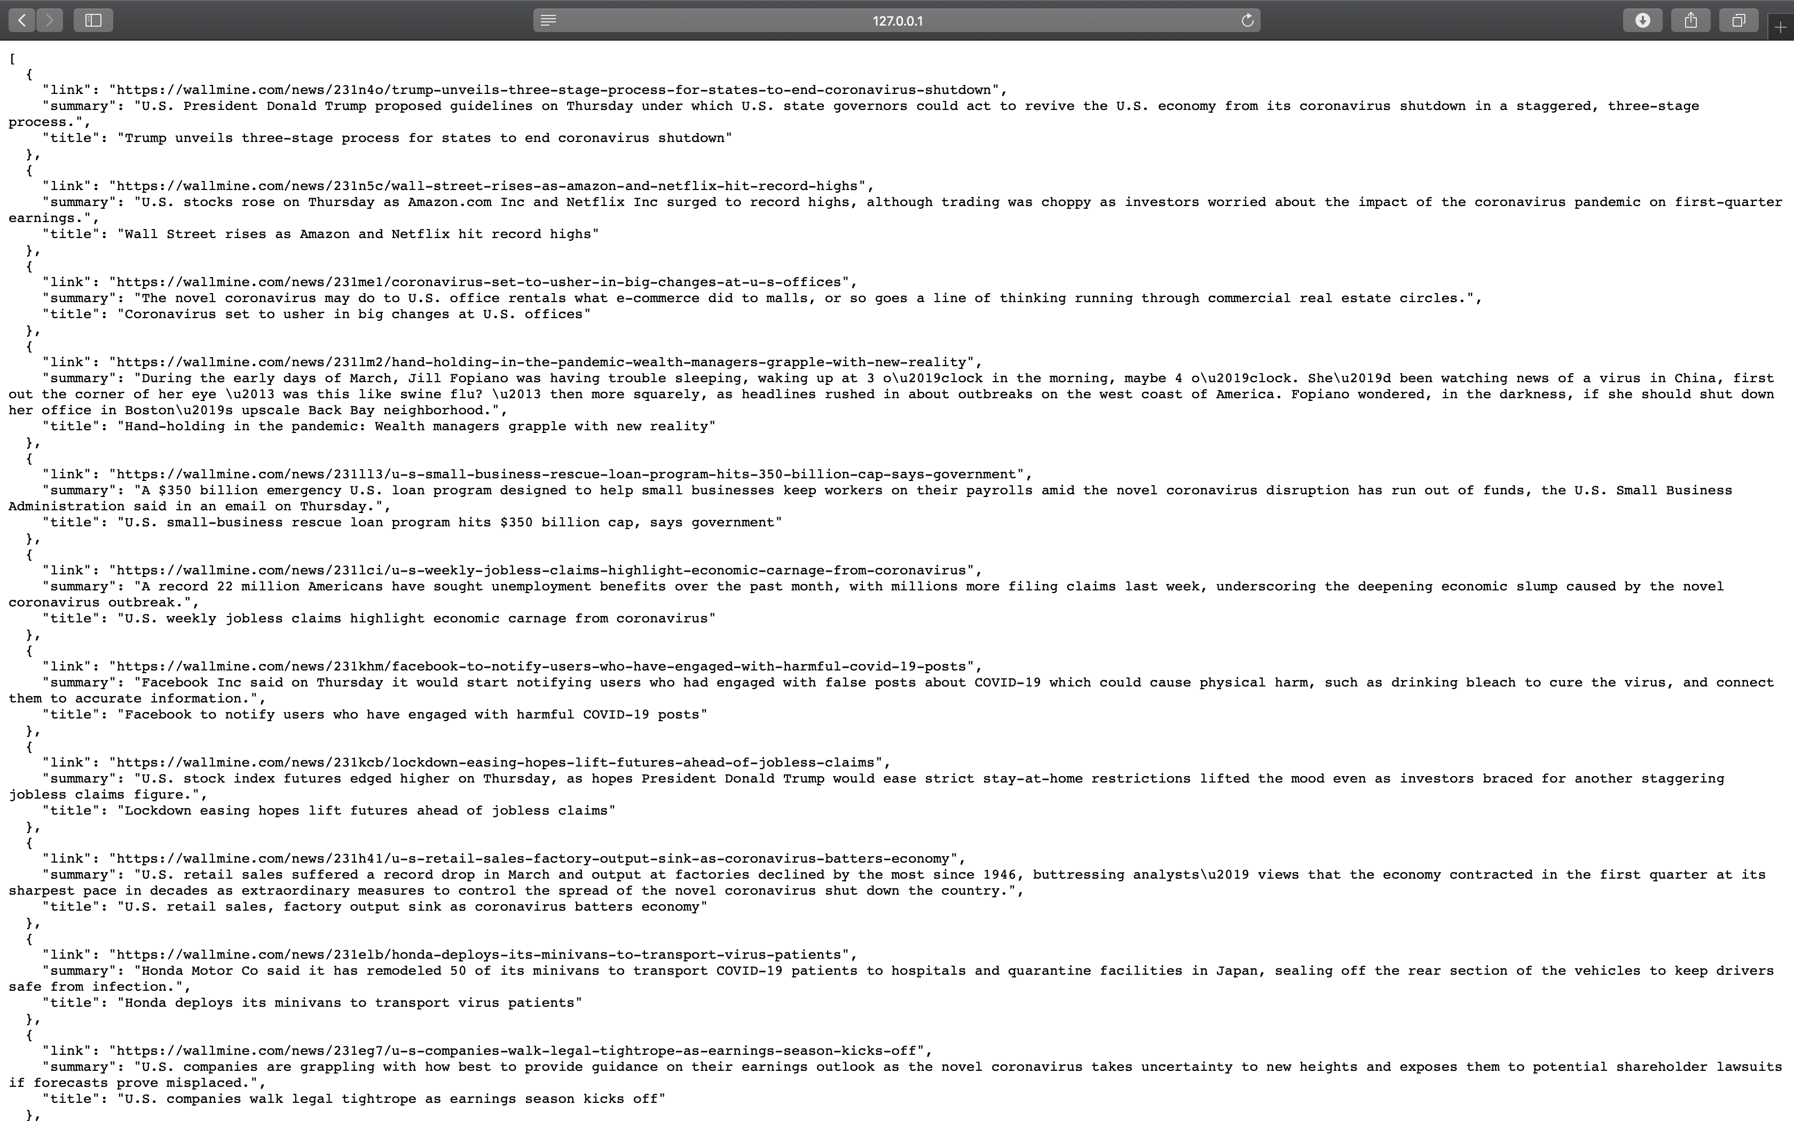

1. Operations and the results: application rendering

Get into folder **FinancialProject** in terminal. Type in **npm install**, then type in **npx react-native run-ios**.

Xcode simulator will pop out the app FinancialProject.

The first screen is Stock List. It shows a list of stocks with stock name, stock symbol and real-time price.

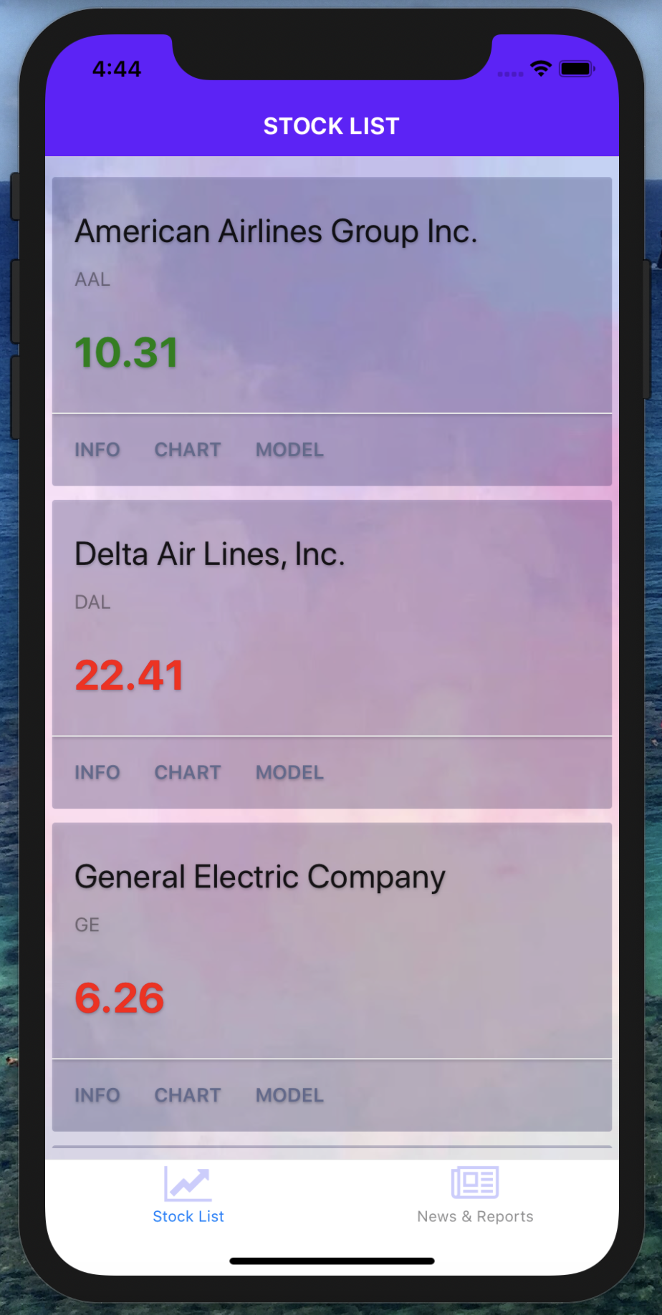

For each stock, there are three buttons: INFO, CHART and MODEL.

Click on button INFO, you can jump to screen Stock Info.

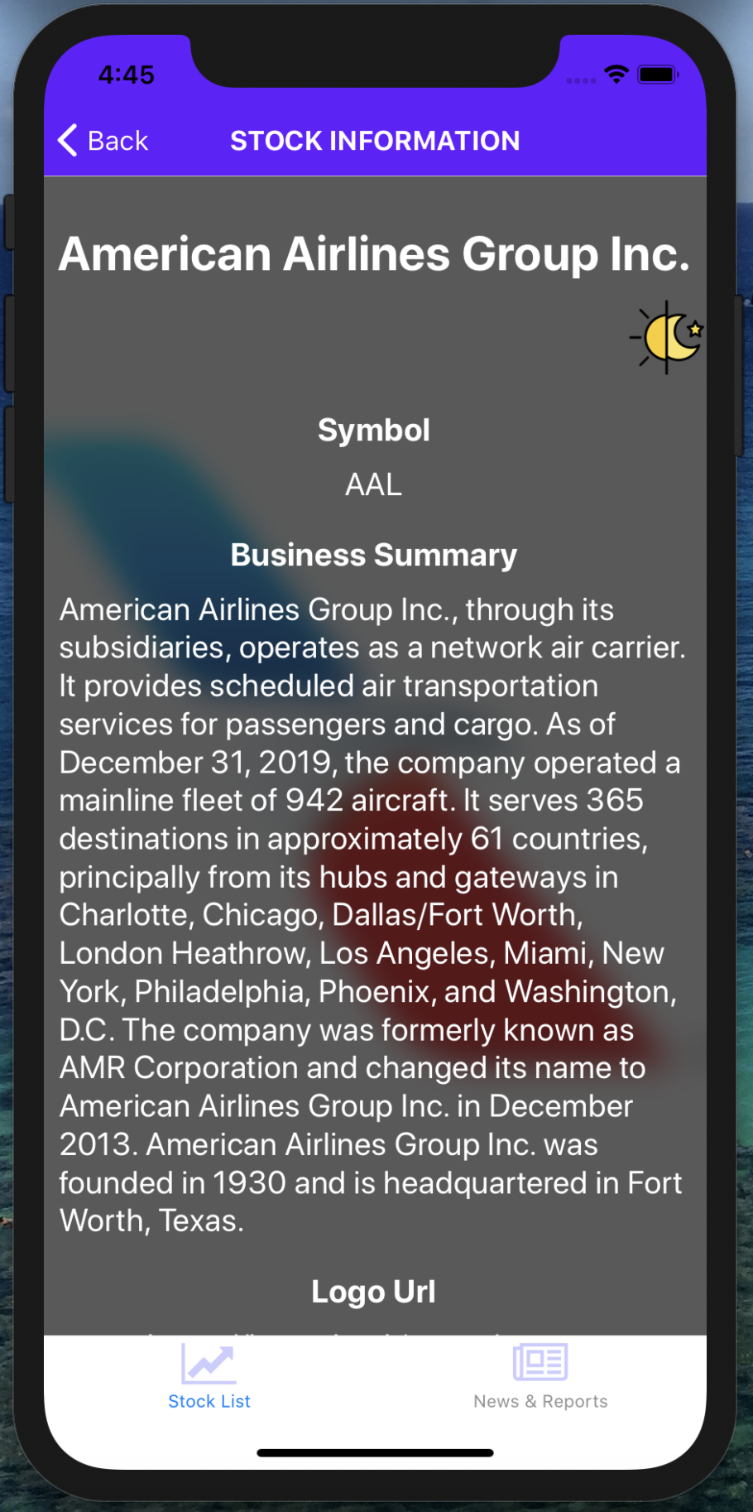 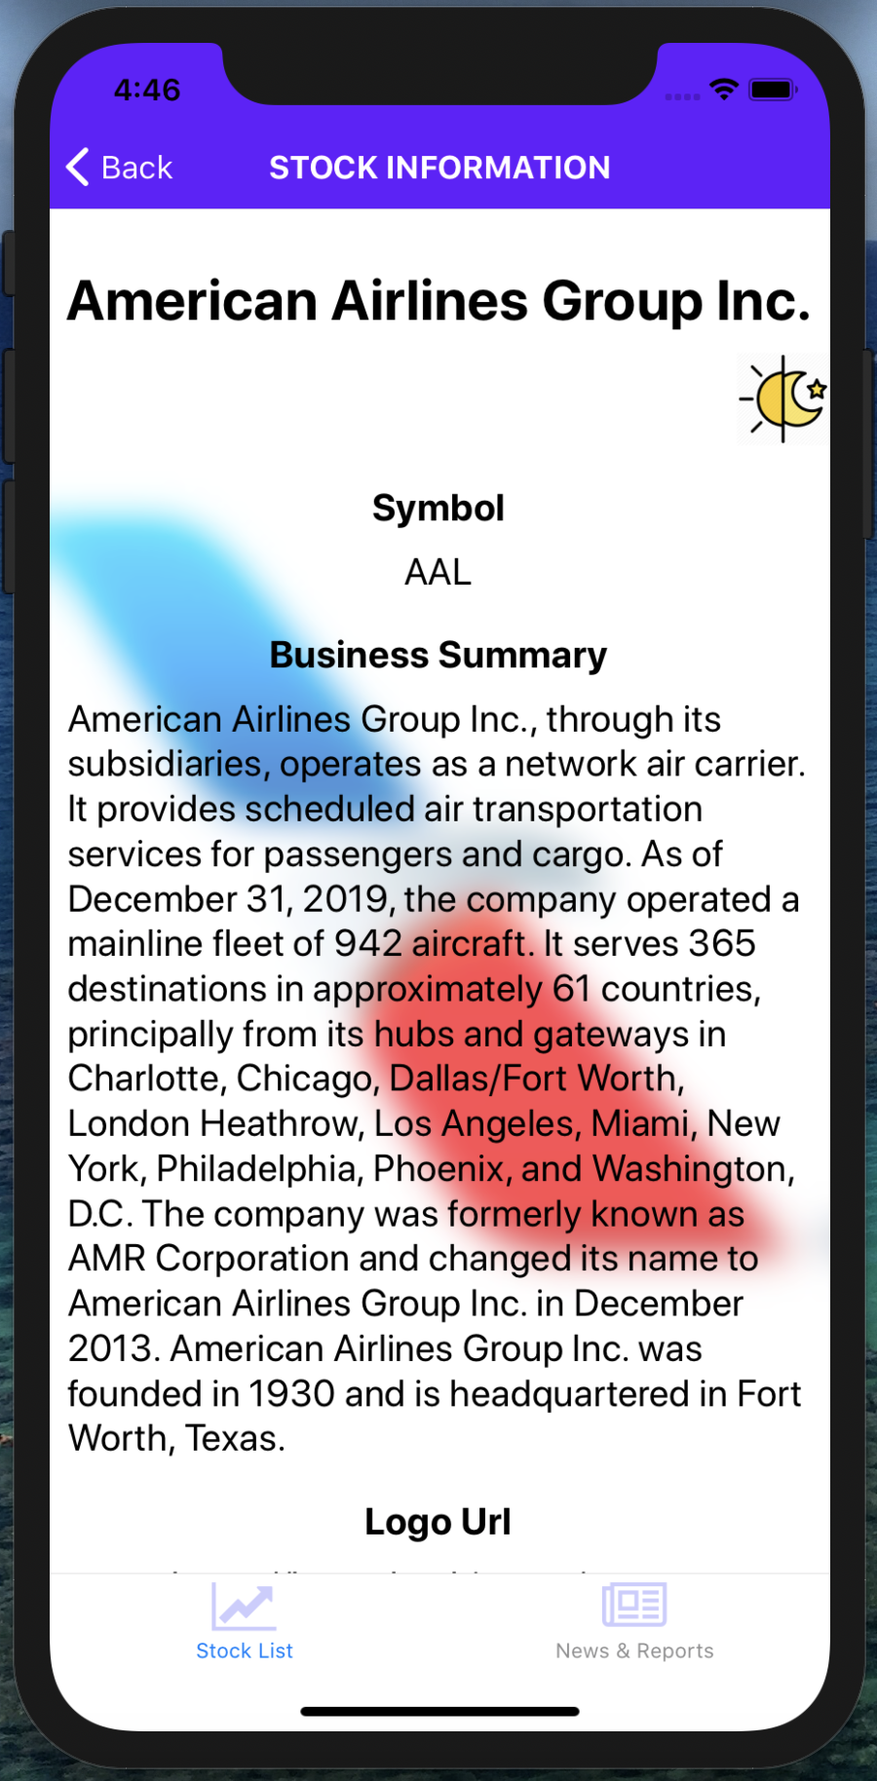

Click on the sun-moon button can change the mode from dark to light.

The screen will show all kinds of info of this stock, including symbol, business summary, logo url, sector, industry, full time employees, city, state, zip code, country, website, phone, fax, market, exchange, exchange time-zone name, exchange time-zone short name, day high, day low, ask, bid, bid size, regular market price, previous close, regular market open, two hundred day average, trailing annual dividend yield, payout ratio, regular market day high, regular market day low, average volume 10 days, etc.

Click on button Stock List, you can go back to the screen Stock List.

Then click on button CHART, you can jump to screen Stock Data.

The initial period is 1 month. The line chart displays the trend of the stock for the most recent month.

You can change period by clicking on buttons.

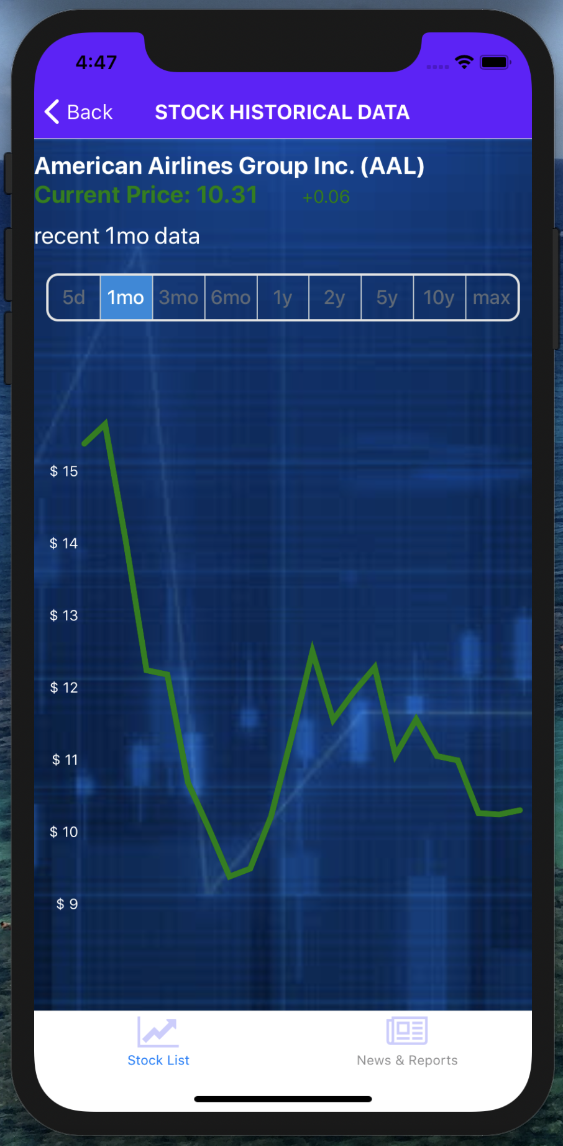

Click on them can change the stock period.

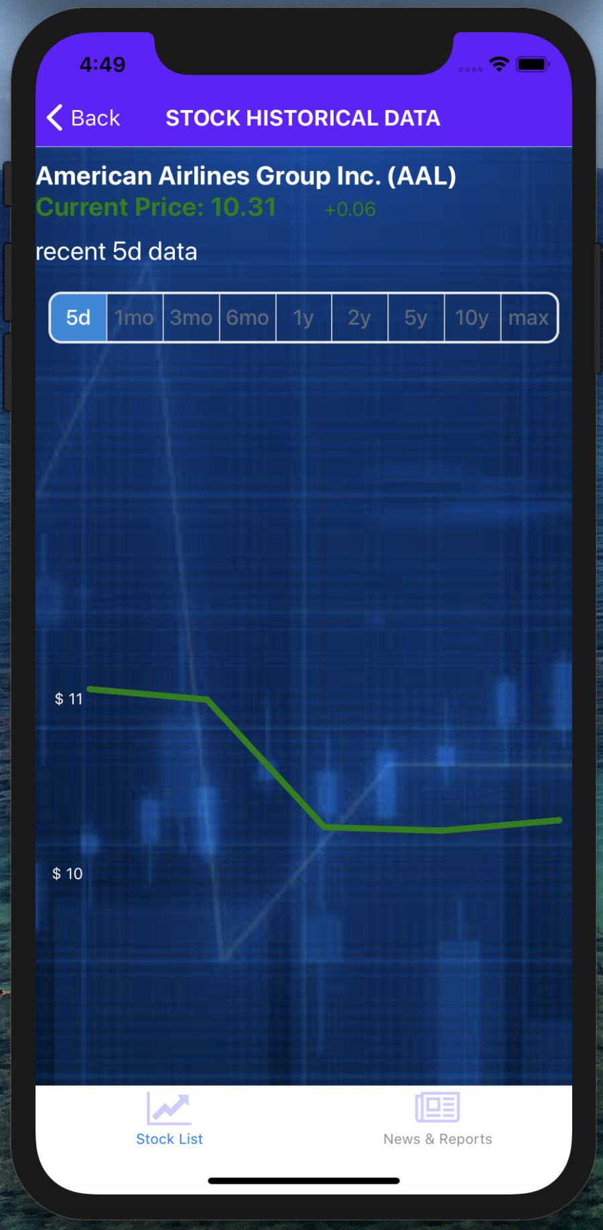 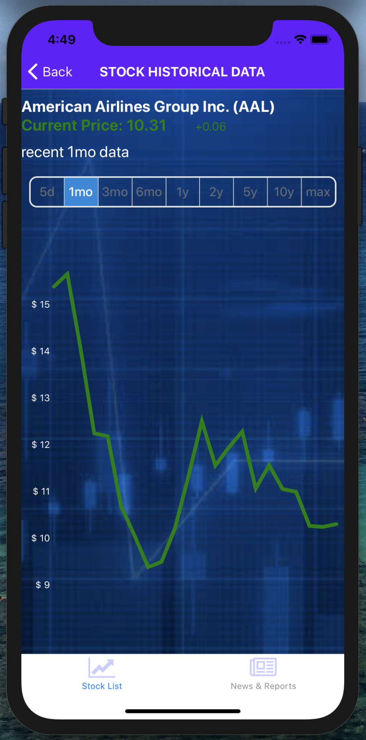

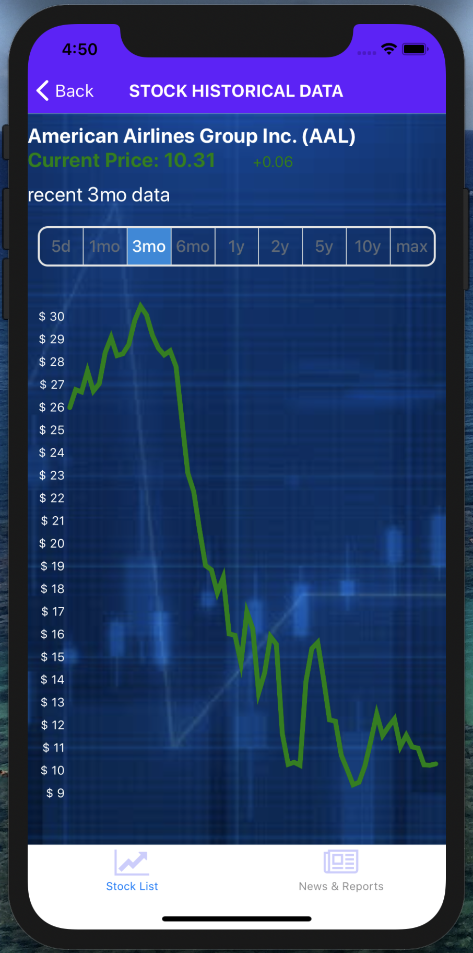 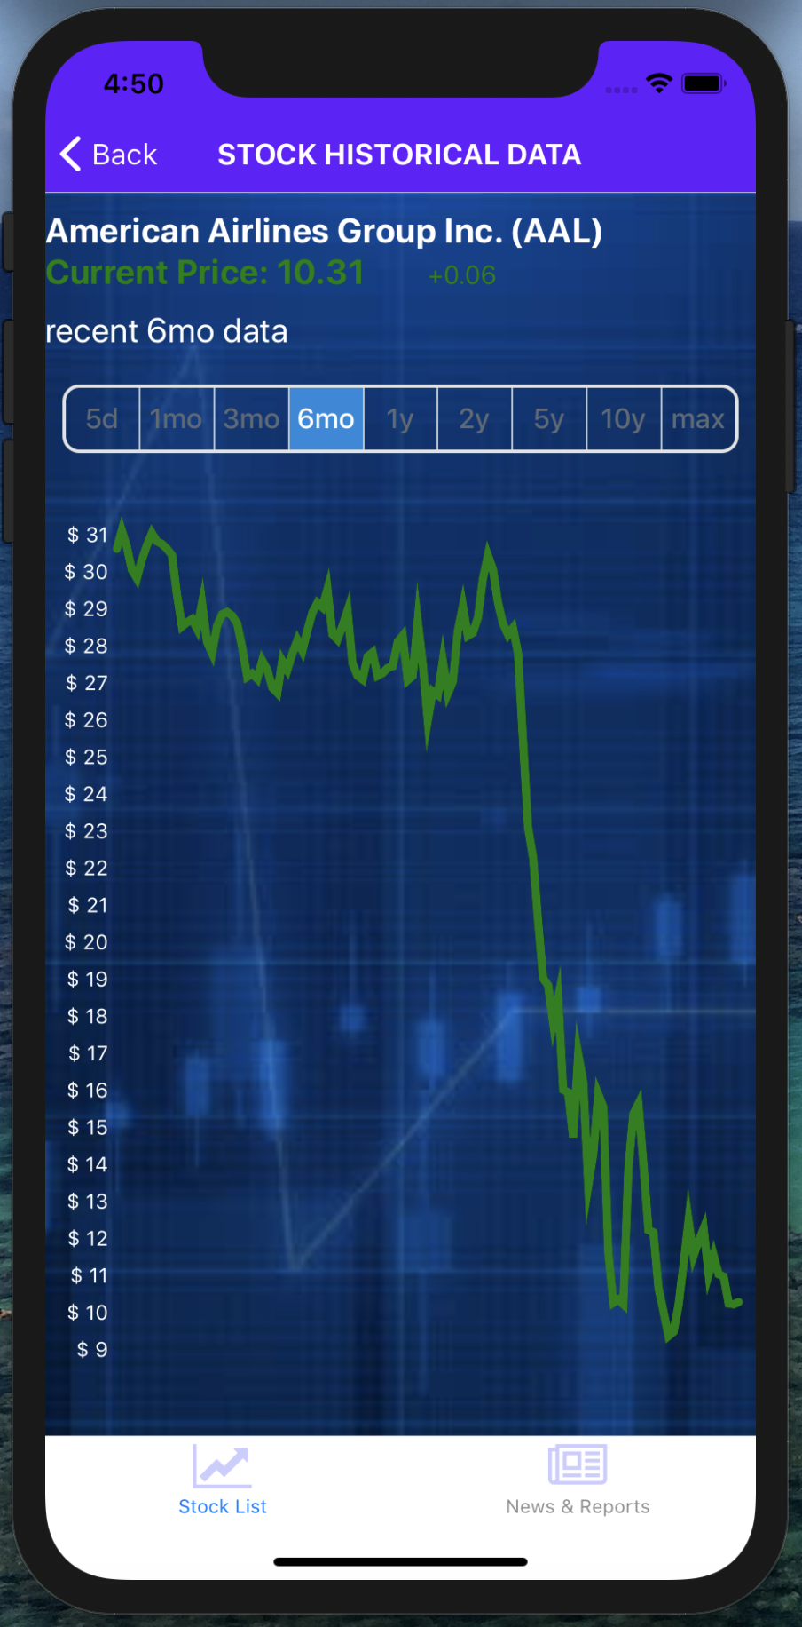

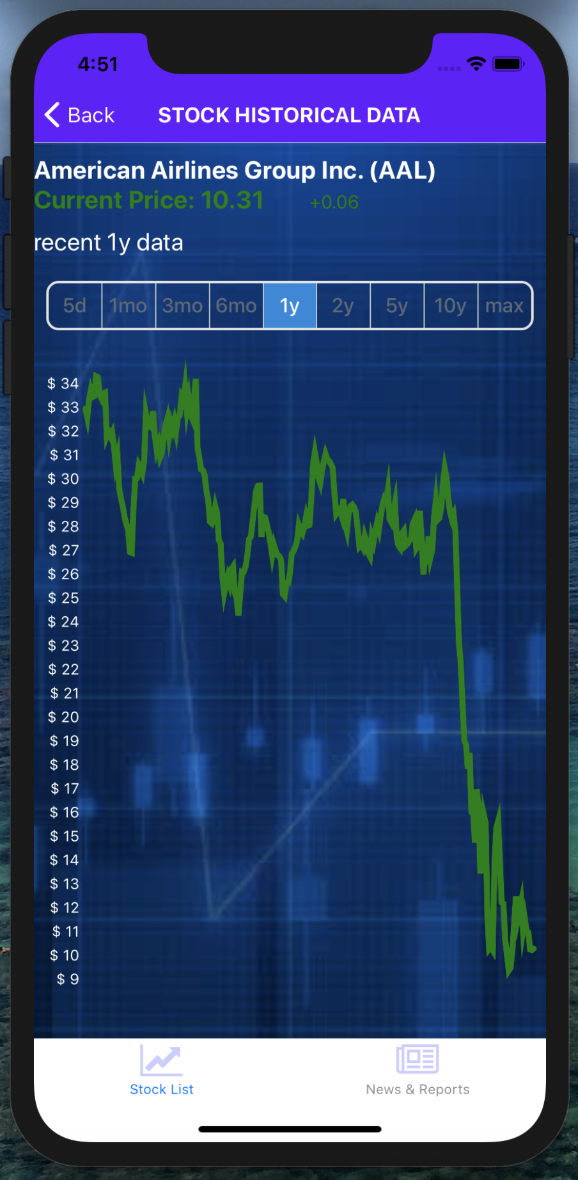 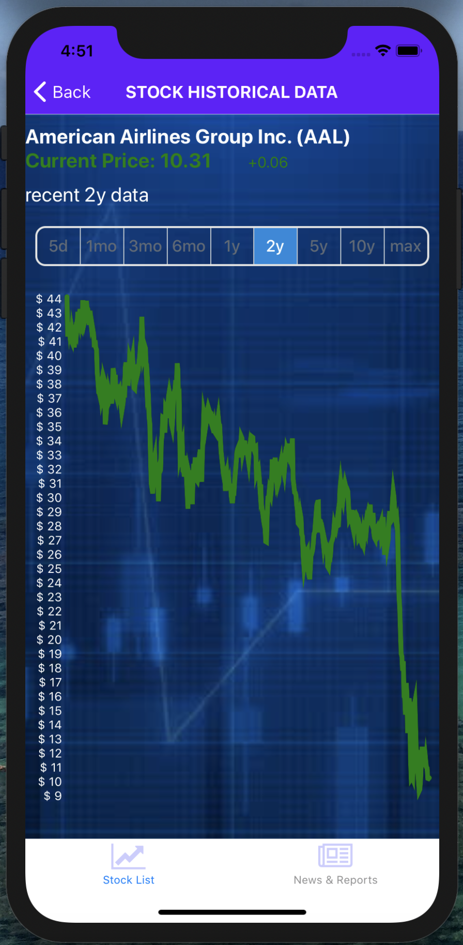

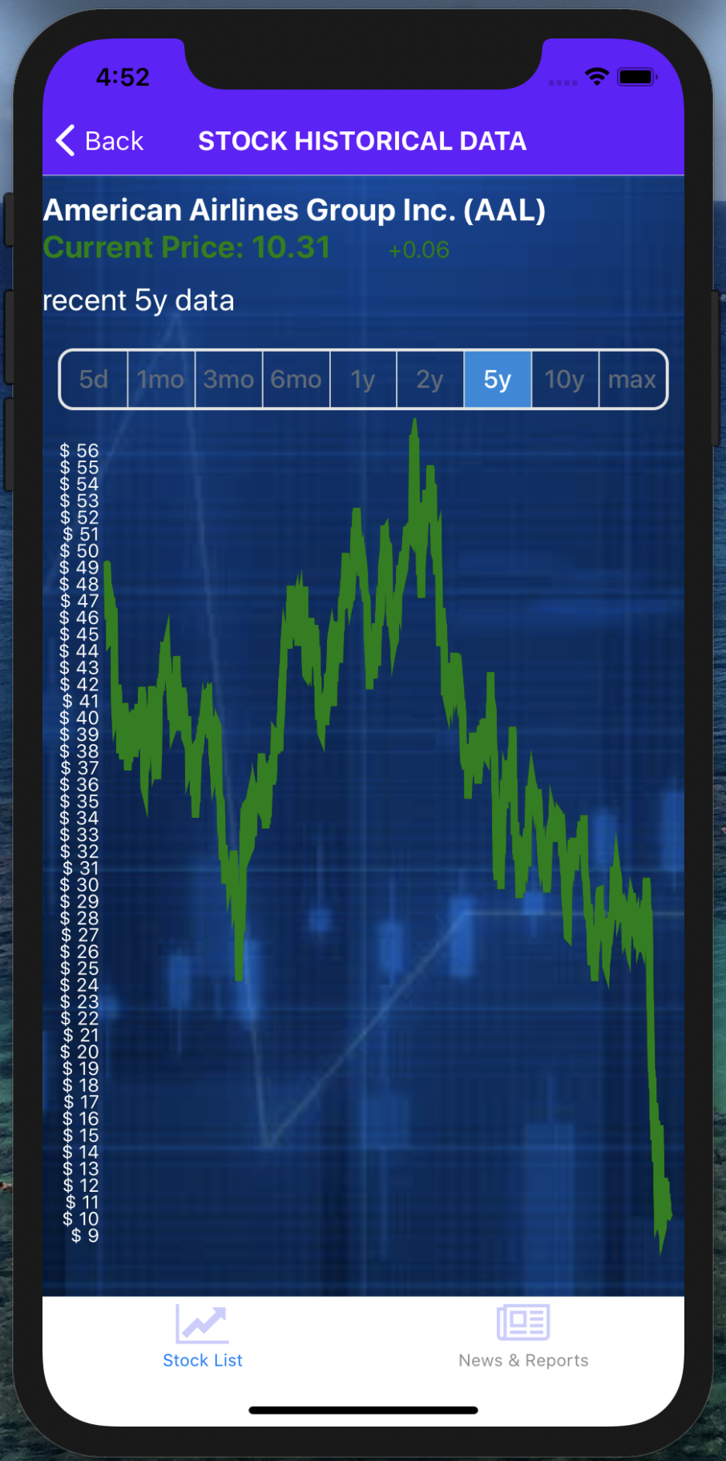 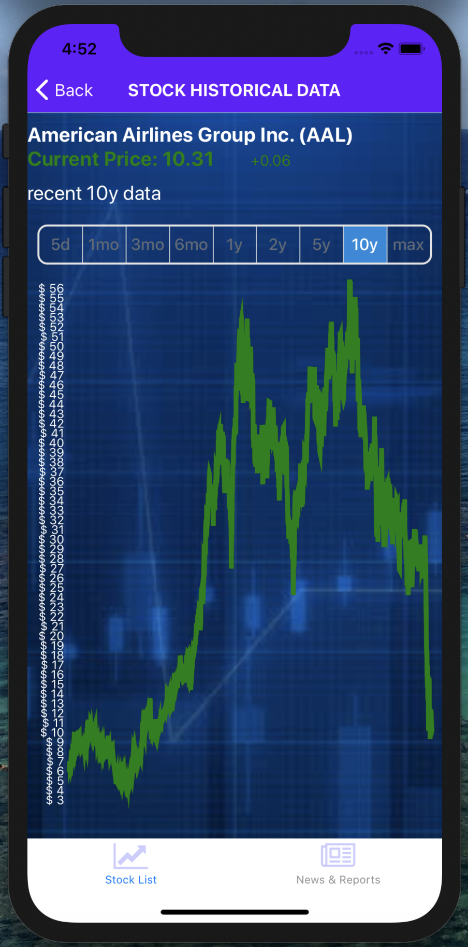

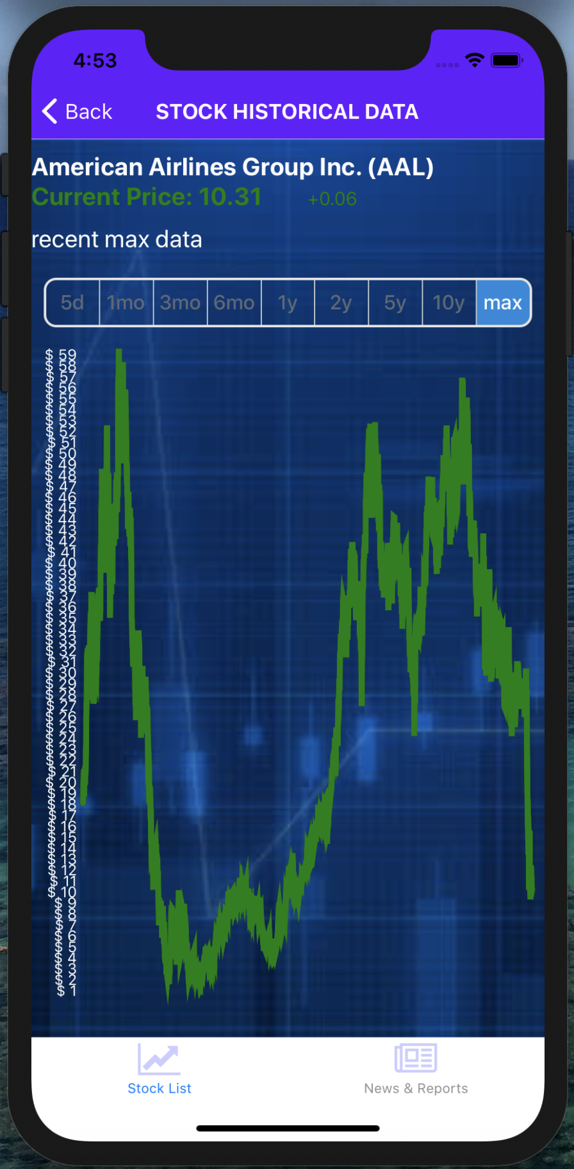

Clicking on the points of trend line shows each point’s data, which is specific stock price.

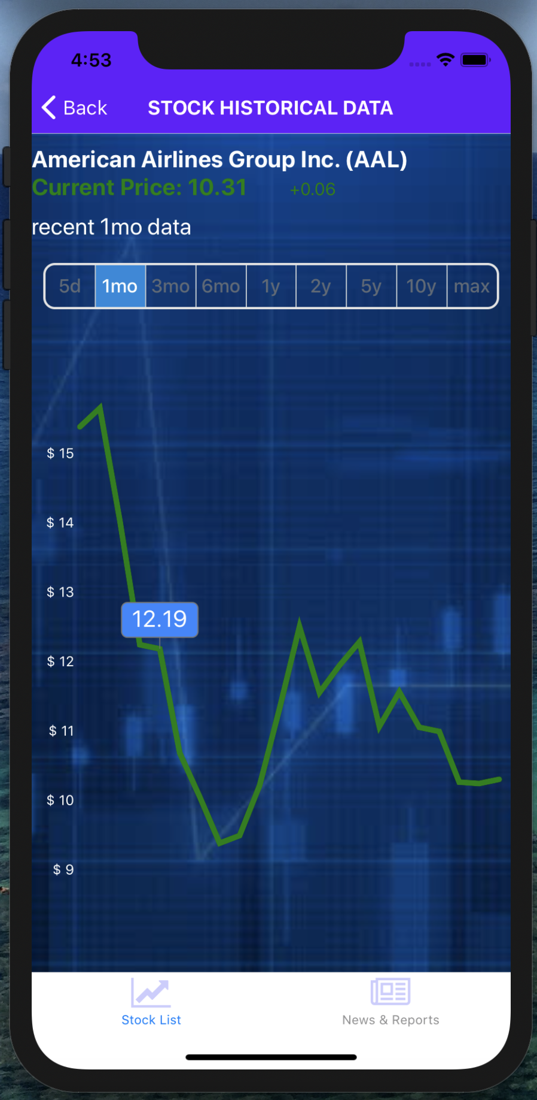

Click on button Stock List, you can go back to the screen Stock List.

Then click on button MODEL, you can jump to screen Stock Model.

This page shows the prediction model, and the result for tomorrow’s stock price.

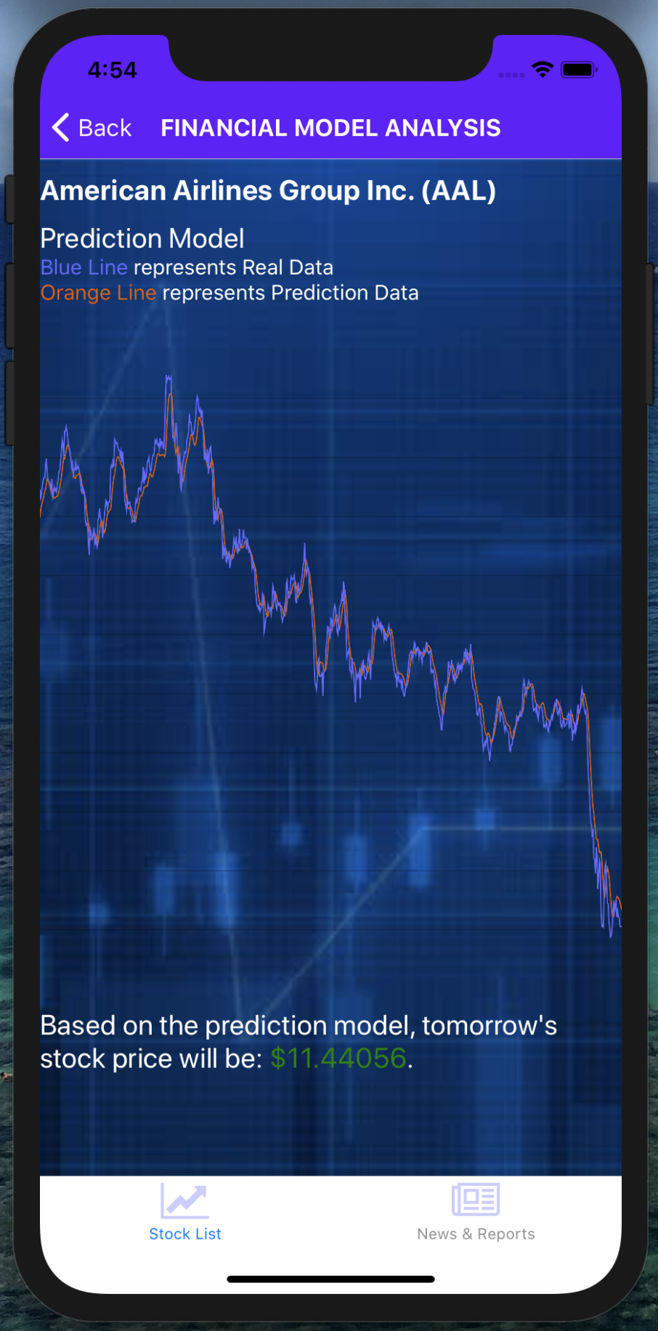

Click on News & Reports button in tab navigator, we can jump to screen News and Reports.

On this screen, you can see a list of news related to stock market.

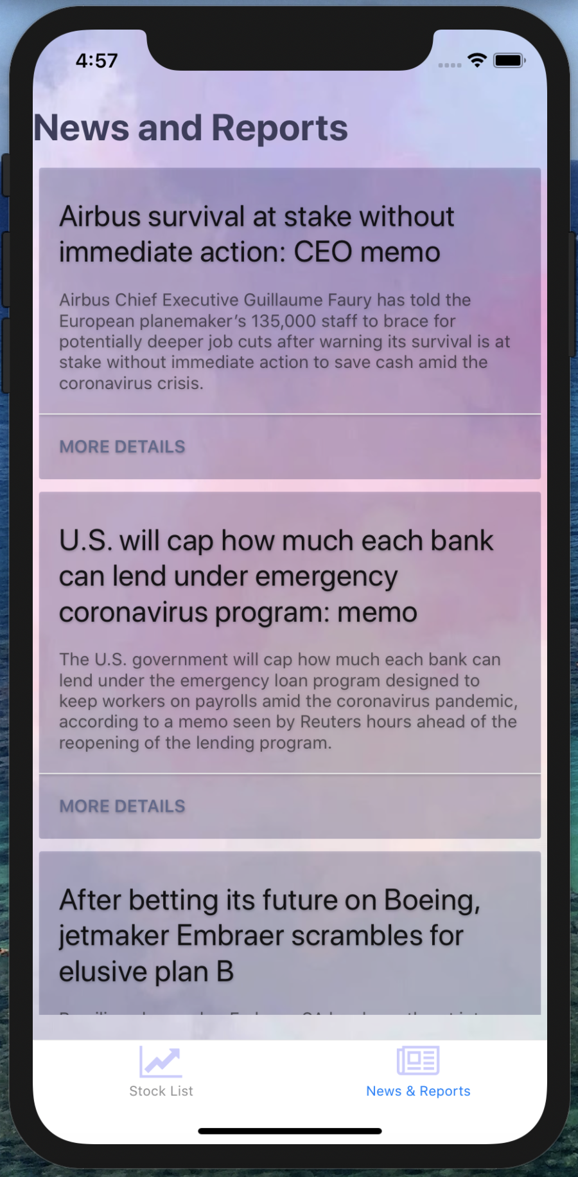

Clicking on button MORE DETAILS can jump to news page.



1. Test Result

API test:

